调整元件参数运行

调整触发角

实验图仿真：

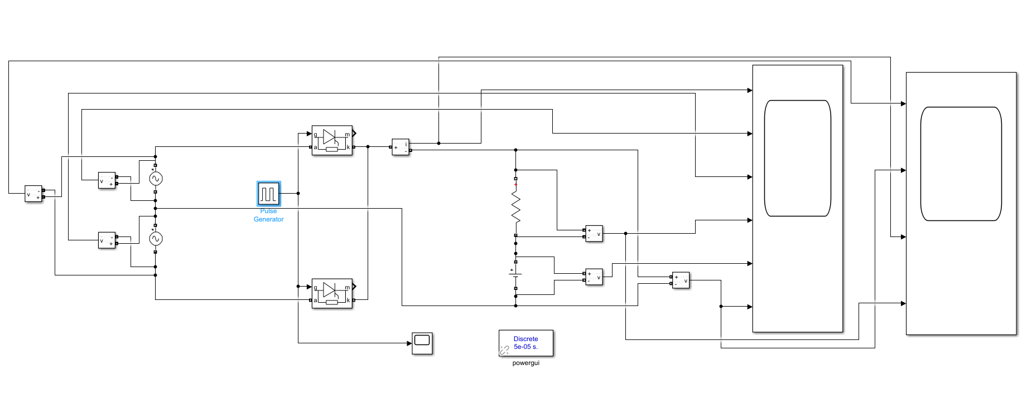

触发角a =15°时,对应的Pulse Generator 器件的参数 Phase delay (secs)=0.000835

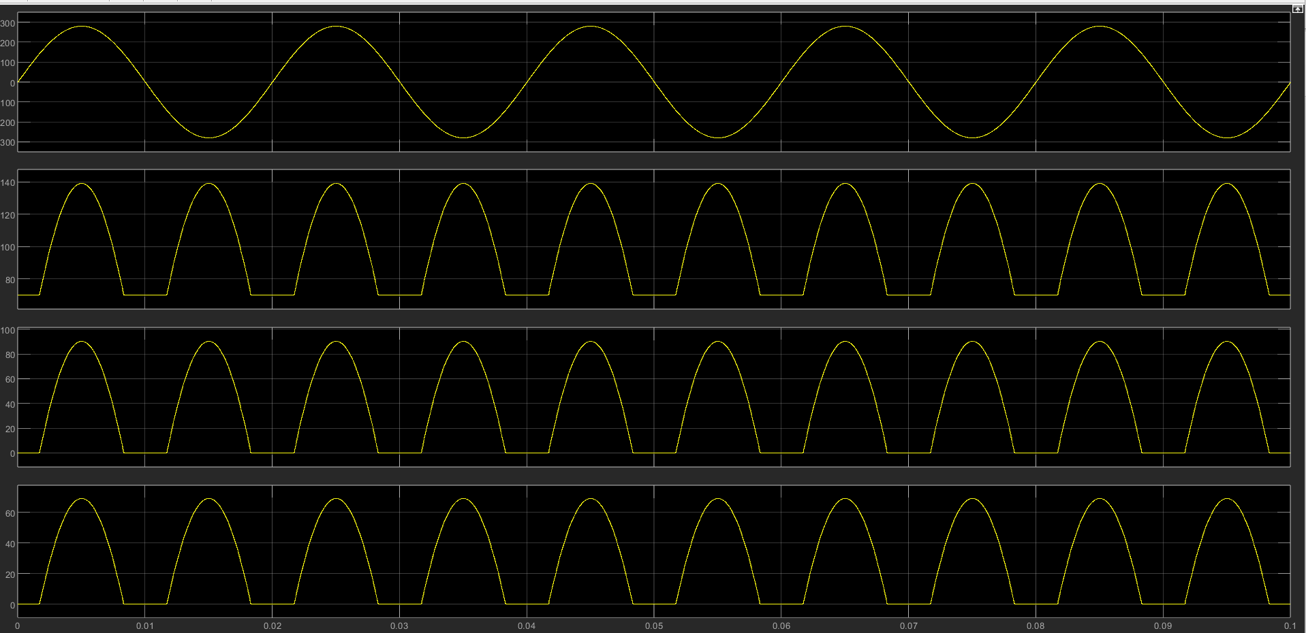

触发角a =30°时,对应的Pulse Generator 器件的参数 Phase delay (secs)=0.00167

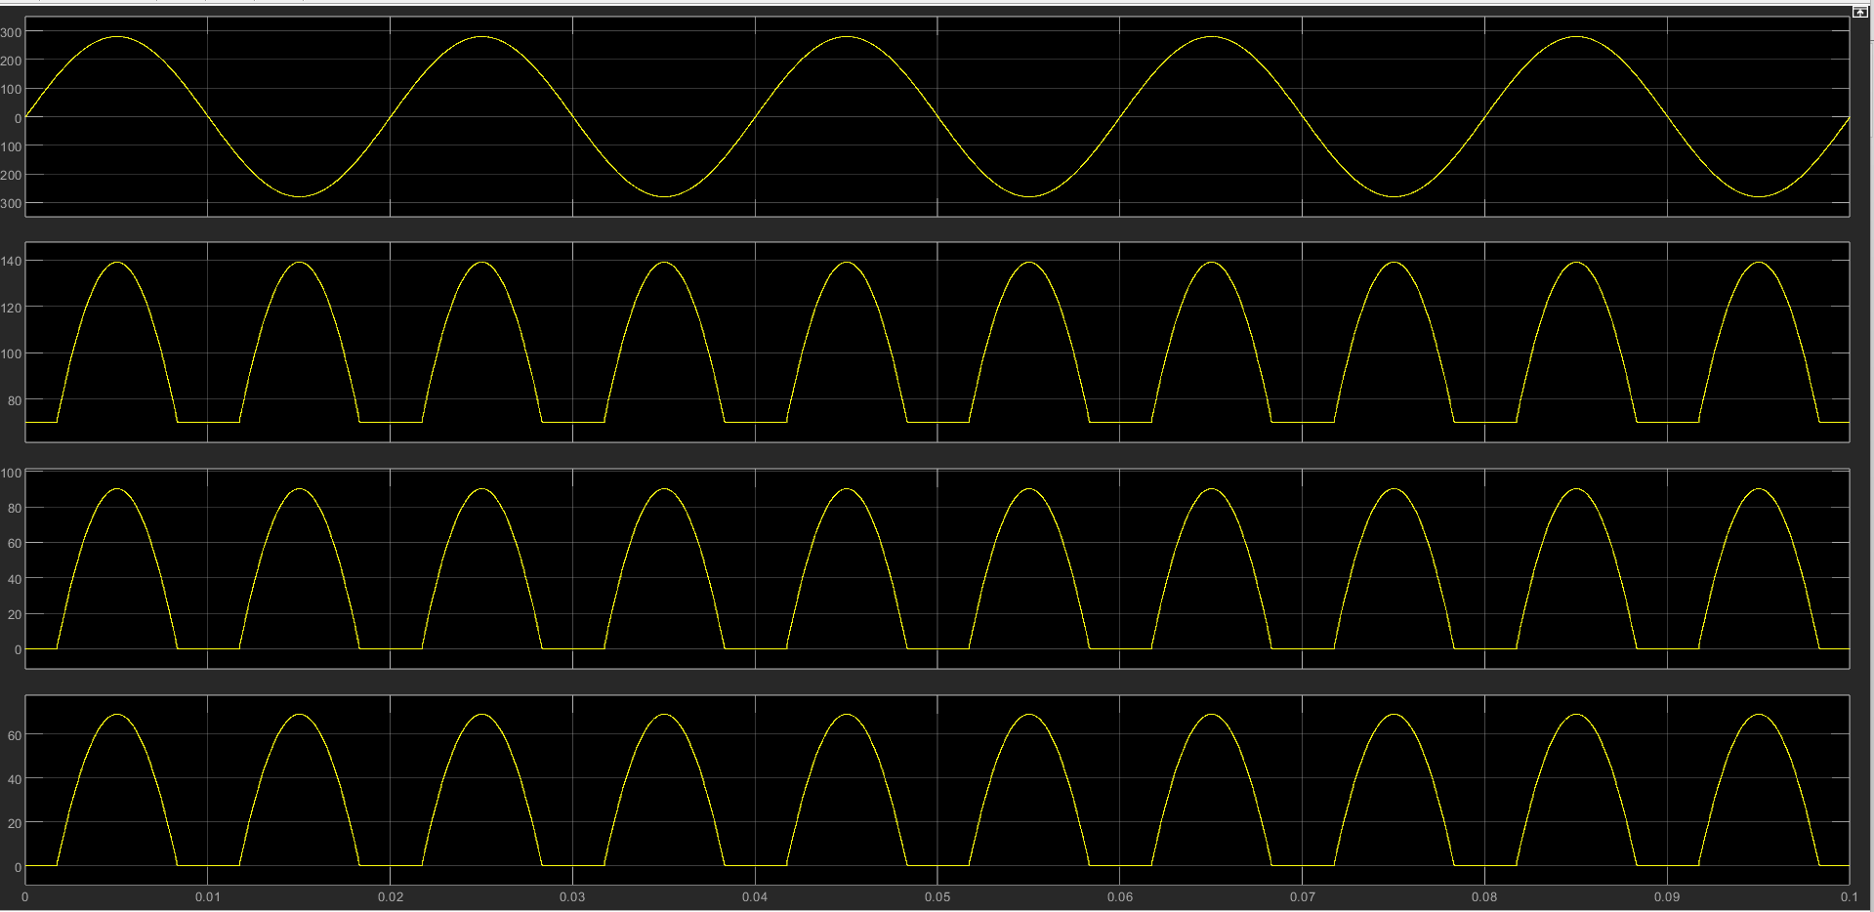

触发角a =45°时,对应的Pulse Generator 器件的参数 Phase delay (secs)=0.0025

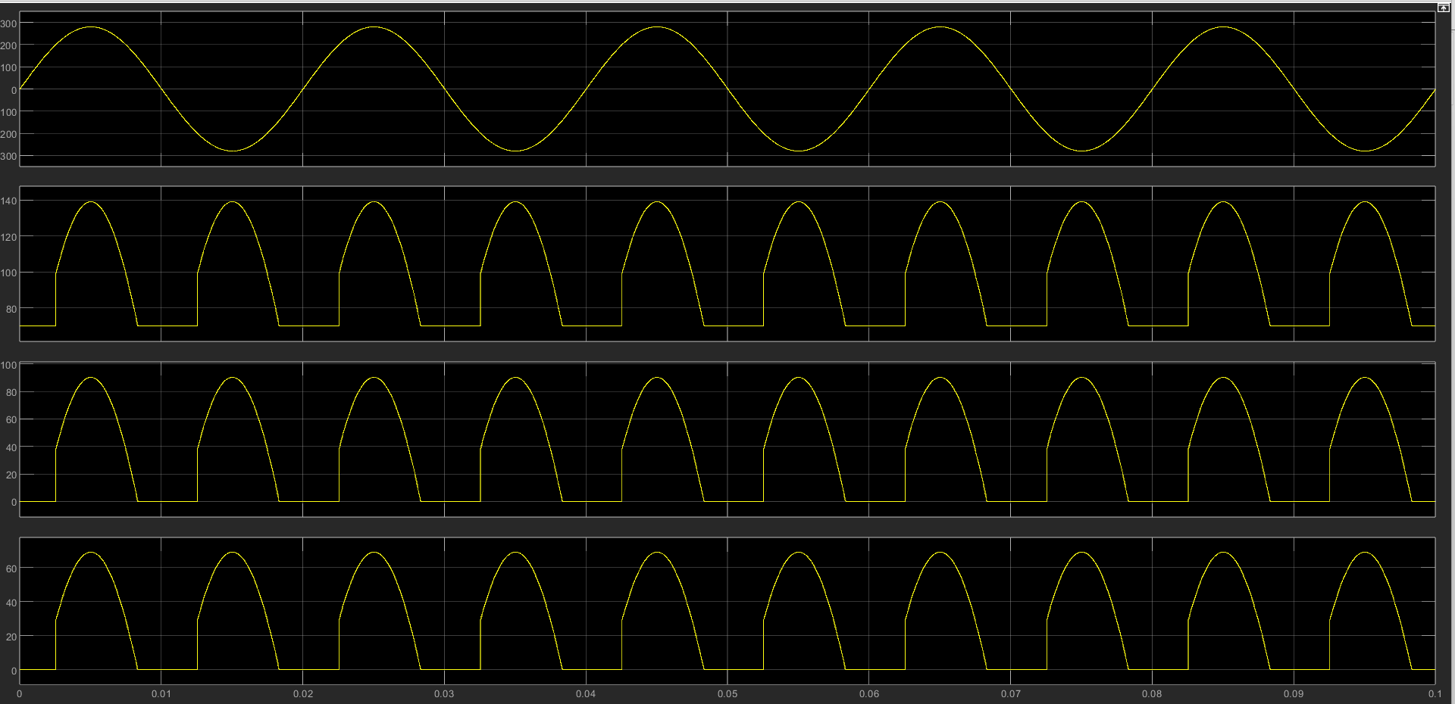

触发角a =60°时,对应的Pulse Generator 器件的参数 Phase delay (secs)=0.00333

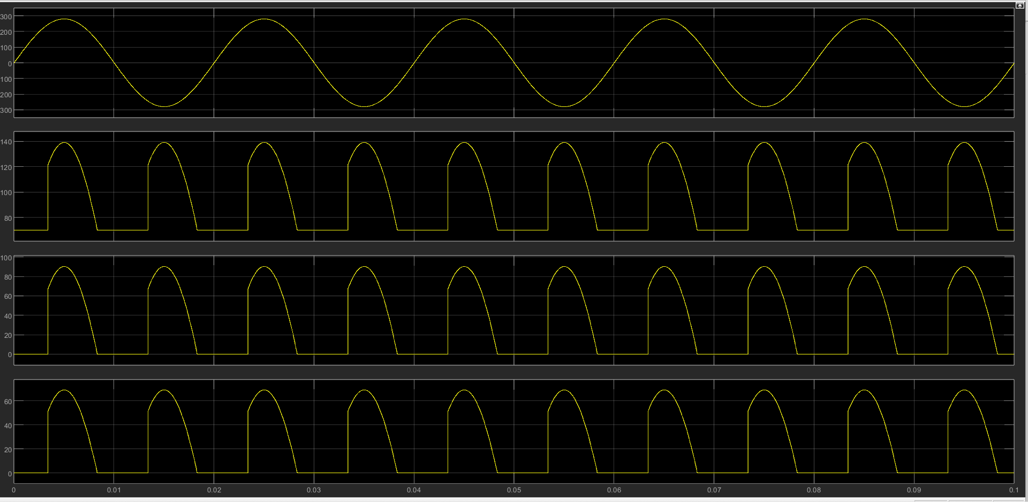

触发角a =90°时,对应的Pulse Generator 器件的参数 Phase delay (secs)=0.005

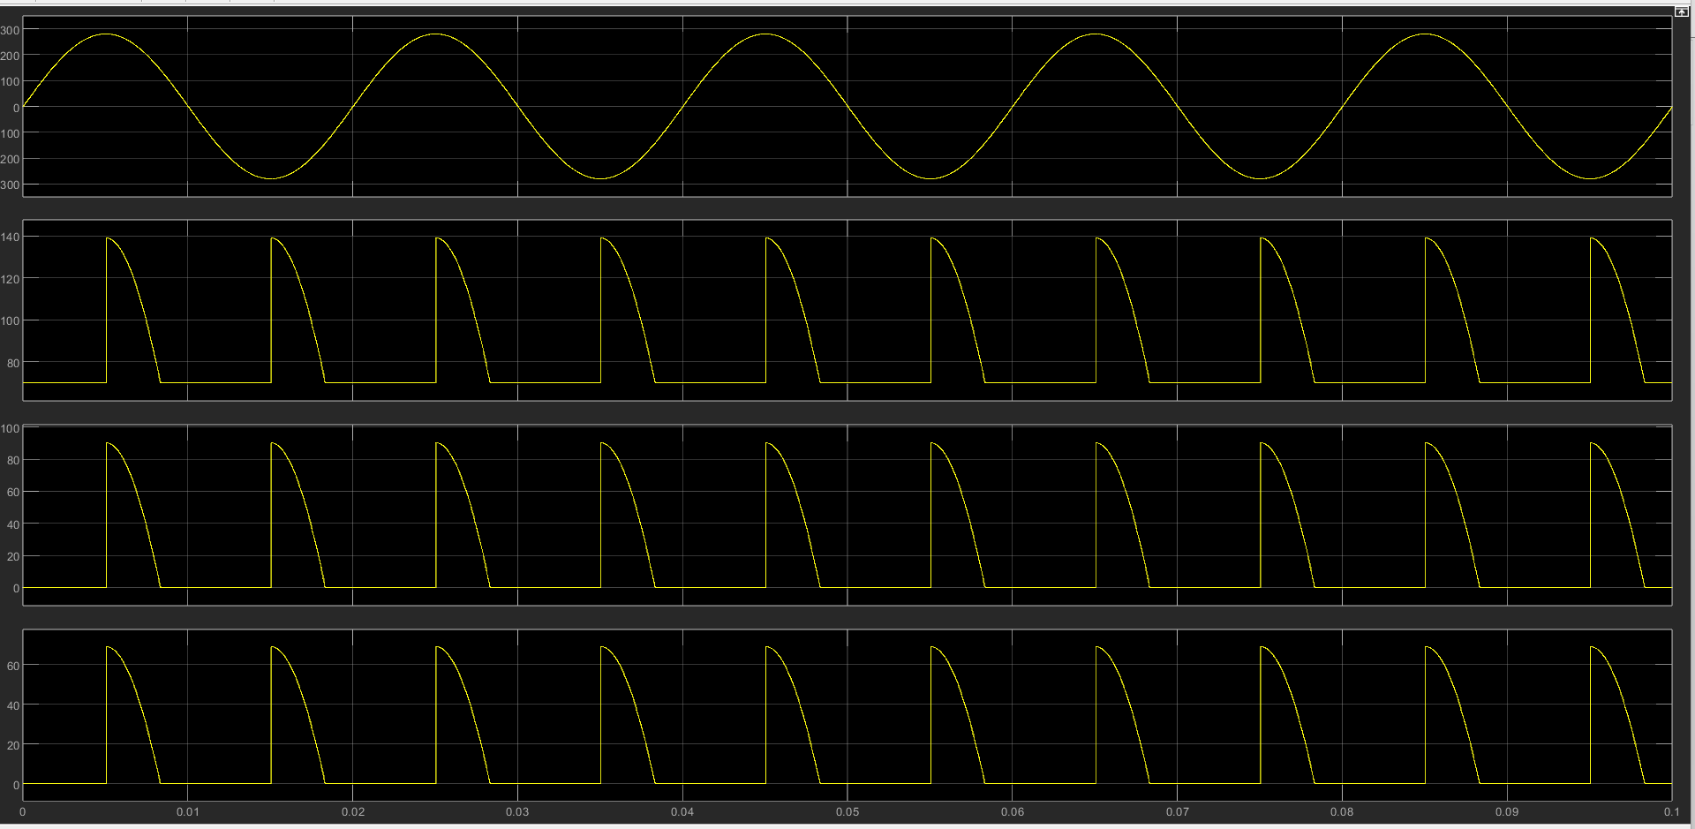

触发角a =120°时,对应的Pulse Generator 器件的参数 Phase delay (secs)=0.00668

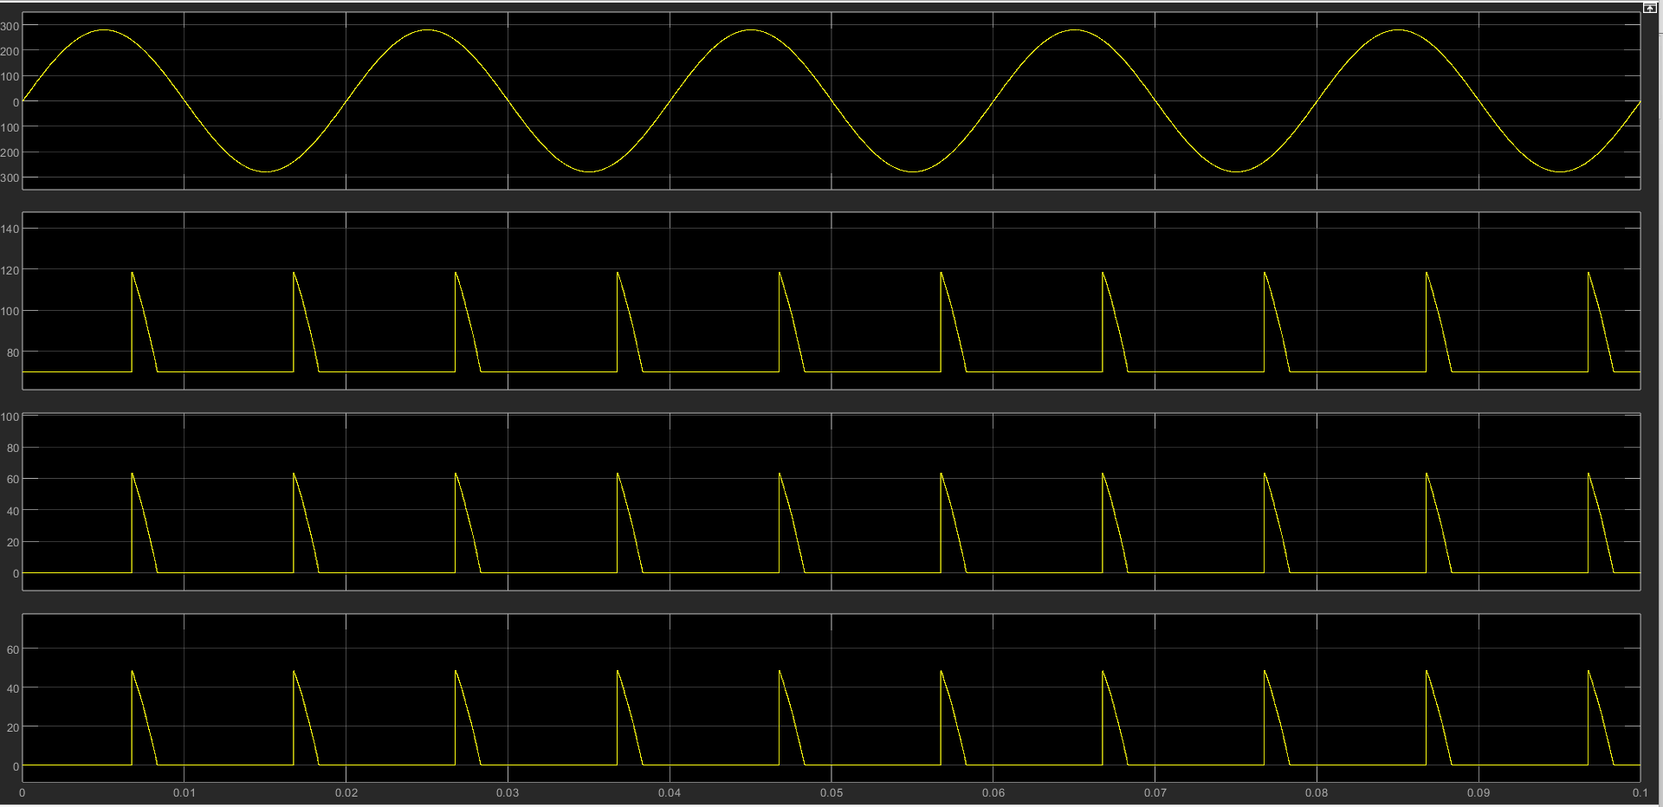

触发角a =135°时,对应的Pulse Generator 器件的参数 Phase delay (secs)=0.0075

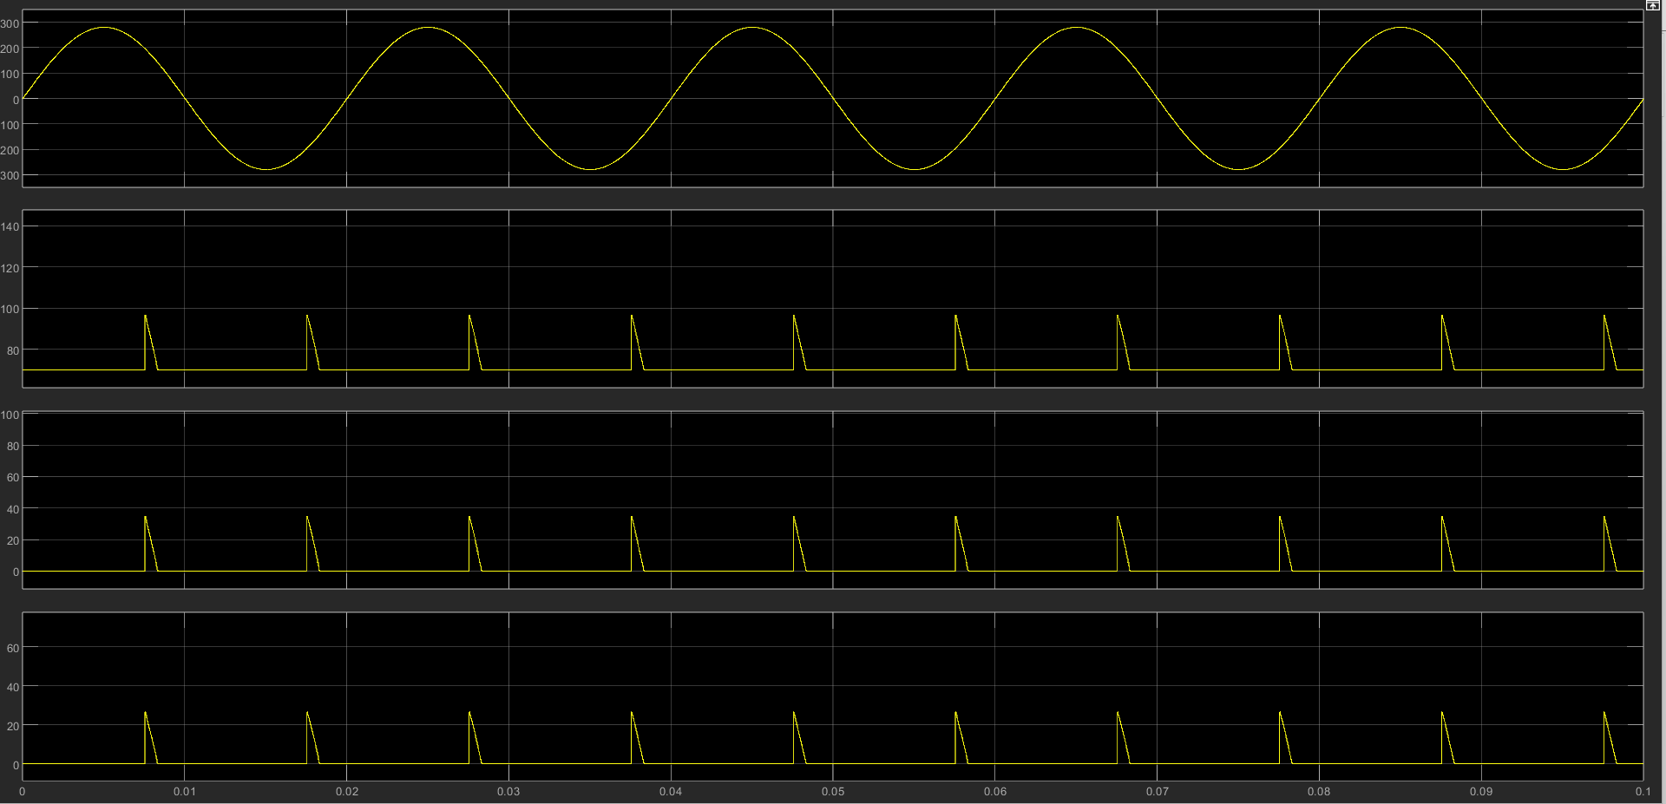

触发角a =150°时,对应的Pulse Generator 器件的参数 Phase delay (secs)=0.00835

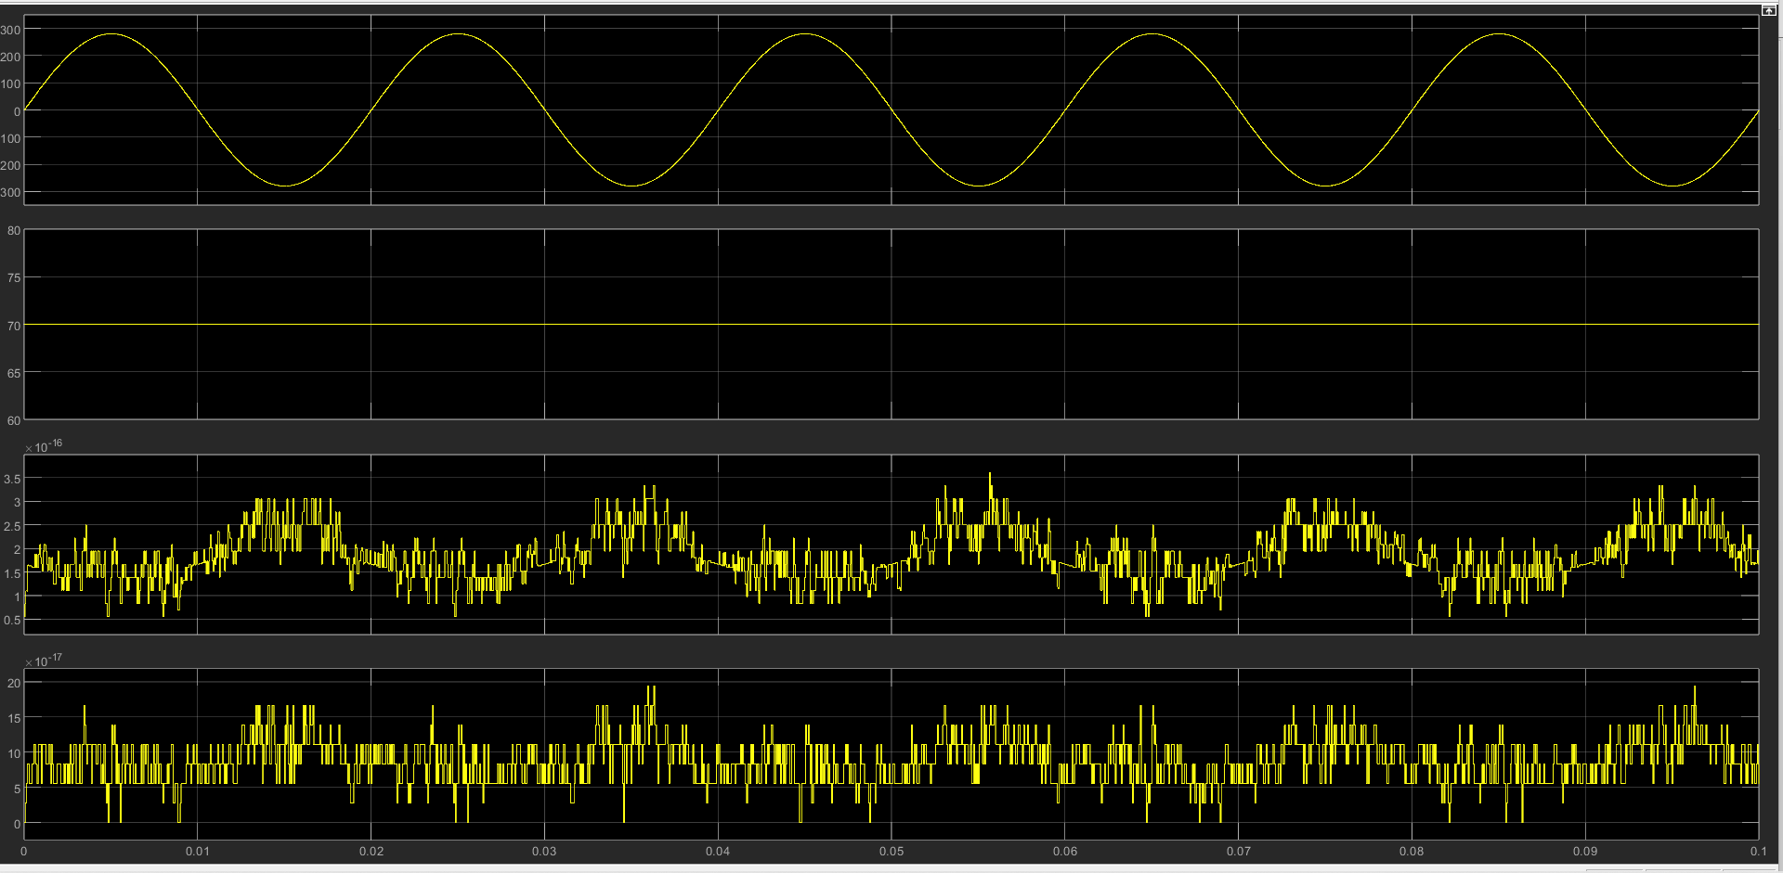

触发角a =165°时,对应的Pulse Generator 器件的参数 Phase delay (secs)=0.009185

（这个数据是多余的，要求里面只要写150°）

